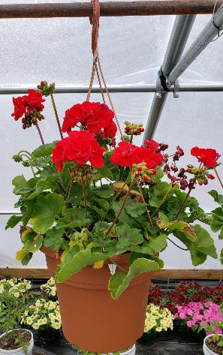
Blue Springs South Jaguar Pride
Spring Flower Sale
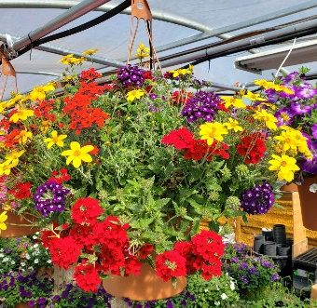
Locally Grown ~ Bennett Family Farm ~ Harrisonville, MO
Mixed flower hanging basket: 10” pot, $22 each
Geranium hanging basket: 10” pot, $22 each
We are unable to select colors. Sorry

Student Name_________________________________
Make Checks payable to BSS Band
Customer name Mixed flower Geranium Total Cost
hanging basket hanging basket
1. Take orders now & collect money
2. Turn in orders & money by April 20, 2022
3. Please write only 1 check for your entire order
4. Flowers will be delivered May 2, 2022 (in time for Mother's Day 😉)
Questions? Contact Christi Gibbs at ibspot@hotmail.com

